ANALYSIS OF COMPREHENSIVE URBANIZATION LEVEL IN FUJIAN PROVINCE OF CHINA
Lijie Lin and Jianfa Shen
Department of Geography and Resource Management
Research Centre for Urban and Regional Development
The Chinese University of Hong Kong, Shatin, NT, Hong Kong
E-mail: lijielin@cuhk.edu.hk; jianfa@cuhk.edu.hk

Abstract
To move beyond demographic urbanization level, the present study attempts to develop an integrated indicator, namely comprehensive urbanization level, to evaluate the comprehensive developing level of urbanization in county-level areas in Fujian Province by taking various aspects into consideration. The analyses have three parts. First, the relationships between demographic urbanization level and other selected indicators on economic and social development were detected by correlation analysis. Second, an integrated indicator of urbanization level was derived by using principle component analysis. Finally, the spatial disparity of the comprehensive urbanization level in Fujian Province was revealed by clustering analysis and discriminant analysis. The county-level areas of Fujian were further categorized into five gradient clusters with very high, high, medium, low and very low urbanization levels.

1. Introduction
Under the background of economic globalization, China’s urbanization has attracted widespread attention. Joseph E. Stiglitz, Nobel laureate in economics, once said that urbanization of China, together with high-tech development in the United States, are two key issues which will reshape the world in the 21st century (Wu, Wu and Wu 2003). As a milestone of the national urbanization process, China’s urbanization level, i.e., the proportion of urban population in total population, crossed the 50% threshold for the first time in 2011. However, a broadly defined urbanization process involves not only population growth, but also economic development and environment change. The proportion of urban population in total population cannot capture the full process of urbanization.
Internationally, due to the lack of uniform definition of cities and towns, the term of urbanization could not be commonly evaluated by normative statistical caliber. For China, using the demographic indicator of urbanization level to assess the urbanization process has following two limitations:
(1) Demographic urbanization level is sensitive to the definition of city and urban population. Owing to the changing and confusing definition of urban area and the inconsistent statistical criteria of urban population in China, terms like “riddle”(Orleans and Burnham 1984), “enigma”(Orleans and Burnham 1984, Shen 1995) and “the statistical mystery in China” (Yan, Lin and Xu 1994) have been frequently used by scholars to describe China’s urban population size and the corresponding index, namely, demographic urbanization level (DUL). Additionally, China’s household registration (hukou) system makes the situation even more complicated.
(2) DUL only focuses on the nominal population size without considering the quality of urbanization. The term of “new form of urbanization” has been proposed in China to reflect the goal of a balanced urbanization path to ultimately achieve rural-urban integration, including the provision of convenient urban public services and facilities, the equality of social welfare and educational opportunities, the coordinated development of spiritual civilization along with material civilization, etc (China Development Research Foundation 2013).
There have been numerous studies which outline the relationships between demographic urbanization and other socioeconomic effects in China (Henderson 2003, Abdel-Rahman, Safarzadeh and Bottomley 2006, Sun, Yan and Liu 2009, Kilkenny 2010, Wang 2010, Bai, Chen and Shi 2011, Chan 2012, Shen, Feng and Wong 2006). Using qualitative methods, the interactions of urbanization and these relevant socioeconomic effects have been well discussed in previous studies. Additionally, some scholars dedicated themselves to the study of China’s urbanization using statistical methods (Fan and Tian 2003, Liu 2004, Fang and Liu 2009, Chen et al. 2014). They have obtained useful results: (1) It is found that there is significant spatial disparity in urbanization and economic development especially between the west and the east in China (Liu 2004, Fan and Tian 2003, Fang and Liu 2009, Chen et al. 2014). In addition, the spatial pattern has been changing over time. For example, Liu (2004) found that the provincial disparity of urbanization has changed from the north-south pattern to the present east-west one since the 1990s. Fang and Liu (2009) found that the provincial disparity began to narrow while there was little change in inter-regional disparity. (2) Some studies focused on the relationships between urbanization and other natural, social and economic factors. They emphasized the important role of economic indicators such as the structure of nonagricultural employment, industrialization level and per capital GDP in the process of urbanization (Fan and Tian 2003, Liu 2004, Chen et al. 2014).
However, most of them studied the urbanization process using statistical models at national or regional scale. The relationship between economic development and urbanization process has also been highlighted. But the role of other factors related to social development has been neglected.
To move beyond demographic urbanization level, the present study attempts to develop an integrated indicator, namely comprehensive urbanization level (CUL), to evaluate the comprehensive development level of urbanization in county-level areas in Fujian Province by taking various aspects into consideration. The rest of the paper is organized as follows. The next two sections introduce the study area and the methodology respectively. They are followed by the main results of analysis. The final section concludes the paper.

2. Research Background: Urbanization and Development in Fujian
Fujian Province is located in the southeast coastal area of China with a total area of 0.124 million square kilometers. According to the 6th national population census in 2010, Fujian had a total population of 36.9 million, including temporary population of 11 million. The temporary population grew dramatically by 87% in the period 2000-2010 (FPC 2013). As shown in Fig.1, Fujian Province consists of 9 prefecture-level cities in 2010. They are divided into 67 county-level area units, including 9 urban areas of prefecture-level cities, 14 county-level cities and 45 counties (excluding Jinmen which is under control of Taiwan).
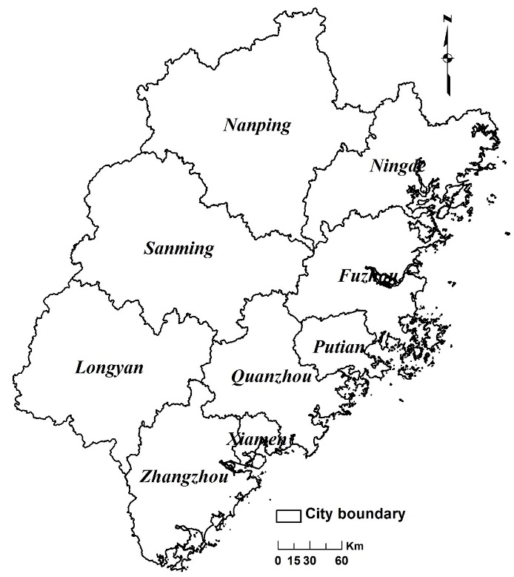
Figure 1. Prefecture-level Cities of Fujian Province
In terms of socioeconomic development, like the Pearl River Delta and the Yangtze River Delta, Fujian has also been at the forefront of reform and opening since 1978. From the perspective of comprehensive economic strength, Fujian Province lagged far behind the Pearl River Delta and the Yangtze River Delta which have been considered as the most prosperous, vigorous and open economic regions in China. But Fujian has a distinct path of urbanization process that has attracted the attentions of some scholars (Chen 2006, Zhu 1998, Zhu et al. 2013, Tan and Ding 2008). Additionally, a key strategy of developing Western Taiwan Strait Economic Zone was proposed in 2004. It is expected that there will be more and more opportunities and challenges not only for Fujian Province, but also for those neighboring regions or provinces as well. A comprehensive evaluation of the urbanization development in Fujian is timely and significant.

2.1 Conceptual Framework
Many attempts have been made to conceptualize the dynamic mechanism of China’s urbanization (Ma and Lin 1993, Ma and Fan 1994, Sit and Yang 1997, Zhu 1998, Ning 1998, Shen, Wong and Feng 2002). It is well known that urbanization is an interdisciplinary issue, involving population growth, economic development, social progress, etc. However, the core issue is essentially population. Based on the concept of dual-track urbanization, a conceptual framework of comprehensive urbanization level is proposed from the perspectives of population, economy and society. This will be used in this study and is shown in Fig. 2.
Owing to hukou system and strong role of the government, the urbanization process in China is unique and clearly different from most Western developed countries. All citizens in mainland China are classified by two categories according to the conditions of residential location and socioeconomic eligibility under hukou system (Chan and Zhang 1999). The former category is the place of hukou registration (hukou suozaidi). The latter one is the status of hukou registration (hukou leibie), further classified as agricultural and nonagricultural hukou (Chan and Zhang 1999). Based on hukou system, the concept of dual-track urbanization has been proposed to describe China’s urbanization in the reform period (Shen et al. 2002). It has two tracks of “state-sponsored urbanization” and “spontaneous urbanization”. The track of state-sponsored refers to the growth of nonagricultural population in urban area while that of spontaneous refers to rural urbanization driven by township and village enterprises (TVEs, private enterprises nowadays) and the rural-urban migration of temporary population (Shen et al. 2002, Shen et al. 2006).
With rapid processes of decentralization, marketization and globalization, the importance of state-owned sector is progressively declined in China’s transitional economy (Lin 2001, Wei 2001, Shen 2004, OECD 2000). Non-state sectors have played an increasingly significant role in the economic growth during the past two decades (OECD 2000).
Based on the ownership, China’s enterprise sectors could be divided into four main classes: state-owned enterprises (SOEs); collectives involving TVEs in rural areas and co-operatives in urban areas; foreign-funded enterprises; and private enterprises (OECD 2000). It is noted that many collective TVEs have been converted into private enterprises in recent years. In fact, the relationship between urbanization and economic growth could be concisely described as follows. Many job opportunities provided by different economic sectors could be considered as the driving force of economic development and population concentration. Population concentration leads to the expansion of urban size. Due to agglomeration economies in production sectors of urban areas, productivity and wage rate may improve significantly. That further promotes the economic development. Therefore, more and more job opportunities are being created and further promote population concentration.
However, the urbanization process not only means population growth and economic development in quantitative terms, but also connotes the improvement in quality. The development of basic public service is essential for the good quality of social life. In fact, hukou is the bond between population and social basic public service. Hukou essentially acts as social welfare allocation system in China especially in pre-reform period (Chan and Zhang 1999). Although the relaxed policy of population migration and employment makes population movement more spontaneous in reform China, the hukou-based disparity of entitlements still exists in social life. The discrimination caused by different hukou status involves agricultural vs. nonagricultural and local vs. non-local. The rural-urban migrants often occupy the jobs in the labor-intensive sectors which are reluctant to be undertaken by urban residents. No matter how long they work and live in urban areas, without local hukou, they are still labelled as ‘peasant workers’ (nongmin gong) and could not enjoy the equivalent entitlements to urban locals (Chan 1996). For example, there are problems of schooling for migrant workers’ children in urban areas and employment discrimination against migrant workers in urban areas.
It is well accepted that the development of basic public service is determined largely by the level of regional economic development. The improvement of basic public service is mainly determined by the fiscal capacity of the state and the local government (Teng and Lin 2012). In a word, from the quantity and quality aspects of urbanization, it could be considered as a comprehensive system with close interactions among population growth, economic development and social changes.
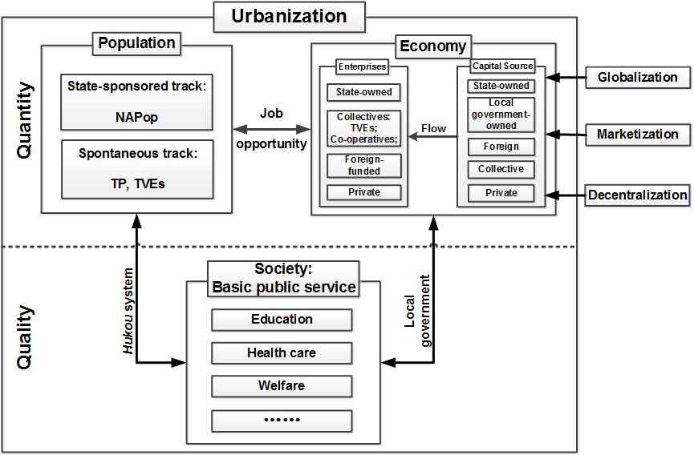
Figure 2. Conceptual Framework of Comprehensive Urbanization Level
Considering the availability and validity of data, 18 indicators (Tab. 1) are selected to reflect dual-track urbanization process in Fujian Province. They are divided into 3 categories which represent the levels of population growth, economic development and social basic public service, respectively. The role of each indicator in comprehensive urbanization level is discussed in the following.
The first category is population indicators. The indicator of NAP (see definition in Tab. 1) reflects the track of state-sponsored urbanization, while that of TP indicates the spontaneous one. The indicator of PD reflects the process of population concentration involving both tracks of state-sponsored and spontaneous. From the perspective of employment structure, the indicator of STemp also manifests these two tracks. State-sponsored urbanization could be represented by nonagricultural population occupied in nonagricultural sectors. Spontaneous urbanization could be detected as agricultural population which appears as temporary population in urban areas or agricultural population occupied in the nonagricultural sectors like TVEs in rural areas without rural-urban migration.
The second category is economic indicators. In the reform period, China has adopted the partial and gradual ways of restructuring the economic system, financial decentralization and the management of state property, including housing and land (Wu 1997). Thus, the indicators of PGDP, LFR and RSCG represent the general economic strength induced by state, local government, as well as spontaneous market behavior. The indicators of S_GDP, S_FAI, T_GDP and T_FAI highlight the economic structures of secondary and tertiary in the urbanization process.
The third category is social indicators. They reflect the ability of state or governments providing social basic public service, including welfare, education, health care, etc. Among the 7 social indicators, HEdu, TeachS and Stu represent the popularized degree of primary education and the level of education service, MedicalS and HBedspace indicate the capacity of medical service and the concern and investment from government, EI and MI show the development level of basic social security and basic medical security.
Table 1 Indicators for comprehensive urbanization level evaluation
Category | Indicators | Minimum | Maximum | Average
Population indicators | NAP: Share of nonagricultural population in total population (%) | 10.08 | 83.49 | 39.06
Population indicators | TP: Share of temporary population in total population (%) | 3.00 | 60.92 | 30.02
Population indicators | PD: Population density  (persons per square km) | 59.62 | 4067.07 | 298.00
Population indicators | STEmp: The share of secondary and tertiary industries in employment (%) | 27.38 | 97.50 | 71.72
Economic indicators | PGDP: Per capita GDP  (thousand RMB/person) | 13.96 | 61.86 | 39.15
Economic indicators | LFR: Per capita local fiscal revenues (thousand RMB/person) | 0.52 | 8.19 | 2.85
Economic indicators | RSCG: Per capita retail sales of consumer goods  (thousand RMB/person) | 4.50 | 40.39 | 14.53
Economic indicators | S_GDP: Share of secondary industry in GDP (%) | 20.36 | 65.11 | 51.05
Economic indicators | S_FAI: Share of secondary industry in fixed asset investment (%) | 8.48 | 80.85 | 35.02
Economic indicators | T_GDP: Share of tertiary industry in GDP (%) | 16.80 | 62.48 | 39.70
Economic indicators | T_FAI: Share of tertiary industry in fixed asset investment (%) | 17.04 | 88.87 | 63.12
Social indicators | HEdu: Ratio of employed population with higher education  (person/1, 000 persons) | 19 | 125 | 53
Social indicators | TeachS: Ratio of teaching staffs to students in primary and secondary education  (person/1, 000 persons) | 5 | 16 | 8
Social indicators | Stu: Ratio of students in primary and secondary education to population  (person/1, 000 persons) | 88 | 178 | 117
Social indicators | MedicalS: Ratio of medical-related staff to population  (person/1, 000 persons) | 2 | 15 | 7
Social indicators | HBedspace: Ratio of hospital beds to population  (set/1, 000 persons) | 1 | 6 | 3
Social indicators | EI: Coverage of endowment insurance (%) | 3.41 | 36.72 | 13.46
Social indicators | MI: Coverage of medical insurance (%) | 3.66 | 40.95 | 14.14
Sources: Derived from Fujian Statistical Yearbook 2011 (FSB 2011), Fujian Office for Population Census 2013 (FPC 2013)

2.2 Methodology
Specifically, the analysis of comprehensive urbanization level includes three major steps (as Fig. 3). First, the relationships between demographic urbanization level and other selected indicators on economic and social development are detected by correlation analysis. Second, an integrated indicator of urbanization level is derived by using principle component analysis. Three principle components without overlapping information are extracted from various socio-economic variables. Finally, the spatial disparity of integrated urbanization level in Fujian Province is revealed by clustering analysis and discriminant analysis. Additionally, the county-level areas of Fujian are further categorized into five gradient clusters with very high, high, medium, low and very low urbanization levels from the point of view of statistical significance. Finally, the spatial pattern of comprehensive urbanization in Fujian Province is revealed.
Figure 3. Flow of Comprehensive Assessment of Urbanization Level

3. Results and Discussion

3.1 Demographic urbanization level and socio-economic development
According to the result of correlation analysis, DUL was highly correlated with 6 variables of NAP, TP, LFR, STEmp, RSCG and EI (as Tab. 2). The spearman correlation coefficients were all over 0.6, and the results were significant at the 0.01 level with two-tailed test. However, owing to partial correlation existed among these variables, it is necessary to use principle component analysis to alleviate the degree of multicollinearity.
Table 2. Correlation coefficients of demographic urbanization level with 18 indicators
Spearman Correlation | TP | STEmp | NAP | LFR | RSCG | EI
DUL | 0.768** | 0.673** | 0.657** | 0.629** | 0.622** | 0.609**
Spearman Correlation | PGDP | MI | HEdu | S_GDP | MedicalS | HBedspace
DUL | 0.588** | 0.524** | 0.519** | 0.375** | 0.370** | 0.336**
Spearman Correlation | T_GDP | PD | Stu | TeachS | T_FAI | S_FAI
DUL | 0.292* | 0.251* | 0.209 | 0.148 | 0.114 | -0.124
**. Correlation is significant at the 0.01 level (2-tailed).
*. Correlation is significant at the 0.05 level (2-tailed).

3.2 Comprehensive urbanization level
Principle component analysis can reduce the mass of confusing information into a relatively small number of uncorrelated components that account for most of the observed variance (Field 2009). Total 18 indicators were considered as variables in the process of principle component analysis. Finally, three major components were extracted, and the cumulative variance was 79.044% of total variance. Once all significant loadings were identified, each component was named based on the patterns of the component loadings (as Tab. 3).
The first component (PC₁) was associated with the variables involving population (NAP; TP; PD; STEmp), economy (PGDP; LFR; RSCG), and society (HEdu; MedicalS; EI; MI). These variables comprehensively reflect the urban development and life quality. The first component is thus named as urban modernization level. It contributes to 50.303% of total variance. With regard to the second component (PC₂), the variables of TeachS (Ratio of teaching staffs to students in primary education), Stu (Ratio of students in primary education to population) and HBedspace (Ratio of hospital beds to population) had relatively high loading. All of these showed the development of science, education, health and other social undertakings. Therefore, the second component is named as urban public service level. It contributes to 16.039% of total variance. As for the third component (PC₃), it is more correlated with the variables of S_GDP (Share of secondary industry in GDP), T_GDP (Share of tertiary industry in GDP), S_FAI (Share of secondary industry in fixed asset investment) and T_FAI (Share of tertiary industry in fixed asset investment). Obviously, these variables belonged to economic indicators, especially the proportion of secondary and tertiary industry. Thus, it is named as urban economic development level. It contributes to 12.702% of total variance.
Table 3 Principle components extraction
Principle Component | Eigenvalue | % of Variance | Variables
PC₁: Urban modernization level | 9.054 | 50.303 | NAP; TP; PD; STEmp;  PGDP; LFR; RSCG;  HEdu; MedicalS; EI; MI
PC₂: Urban public service level | 2.887 | 16.039 | TeachS; Stu; HBedspace
PC₃: Urban economic development level | 2.286 | 12.702 | S_GDP; T_GDP; S_FAI; T_FAI

Finally, the overall score of each area unit, which represents CUL, could be calculated, weighted by relative variance contribution of each component (see equation 1). Tab. 4 showed the order of each component score, CUL and DUL.

CUL=0.636×PC₁+0.203×PC₂+0.161×PC₃ (1)

Urban areas (UA) of prefecture-level cities occupied the majority of top 10 in the score of PC₁, urban modernization level. Some county-level cities and counties had higher urban public service level than many urban areas of prefecture-level cities. All of the top 10 area units in PC₂ (Urban public service level) were county-level cities and counties under the prefecture level cities of Putian, Quanzhou, Fuzhou and Xiamen. In other words, these 4 coastal prefecture-level cities could provide the relatively higher urban public service than other cities in Fujian. The secondary and tertiary industries related variables were highly loaded in PC₃ (Urban economic development level) and all of the top 10 area units in PC₃ were county-level cities and counties. It demonstrated that the county-level economy played a significant role in promoting the economic growth in Fujian Province. However, all of the area units were in the coastal prefecture-level cities.
With regard to the order of CUL based on the overall component scores, Shishi and Jinjiang were the only two county-level cities that were among the top 10. Due to the prosperity of township and village enterprises, Shishi and Jinjiang were well-known for the highly developed in-situ urbanization in Fujian Province (Zhu 2000, Zhu 2002). On the other hand, the ranks of DUL and CUL are different. For example, Xiamen UA, Quanzhou UA, Longyan, UA Putian UA and Nanping UA have higher ranks in CUL than in DUL while Zhangzhou UA is ranked no. 4 in both CUL and DUL. Actually, CUL is much closer to the actual urbanization by taking into consideration of other social-economic indicators.

Table 4 Area ranking by component score
Rank | PC₁ | PC₂ | PC₃ | CUL | DUL
1 | Fuzhou UA | Jinjiang | Jinjiang | Xiamen UA | Fuzhou UA
2 | Xiamen UA | Putian UA | Luoyuan | Fuzhou UA | Xiamen UA
3 | Sanming UA | Nan'an | Changle | Quanzhou UA | Sanming UA
4 | Quanzhou UA | Pingtan | Hui’an | Zhangzhou UA | Zhangzhou UA
5 | Zhangzhou UA | Anxi | Shishi | Sanming UA | Quanzhou UA
6 | Longyan UA | Shishi | Nan'an | Longyan UA | Shishi
7 | Shishi | Xianyou | Changtai | Shishi | Dehua
8 | Nanping UA | Fuqing | Minqing | Jinjiang | Longyan UA
9 | Yong’an | Lianjiang | Longhai | Putian UA | Shaowu
10 | Jinjiang | Xiamen UA | Zherong | Nanping UA | Nanping UA
Notes: UA refers to urban areas

3.3 Spatial disparity of comprehensive urbanization level
With the aid of cluster analysis, individual area units with similar statistical characteristics could be divided into several groups or clusters based on the scores of three principle components. By using hierarchical clustering method with the Euclidean distance linkage, five clusters were generated. These five clusters were labelled as areas with very high, high, medium, low and very low levels of urbanization. After getting the prior knowledge of group membership, discriminant analysis was used to verify the accuracy of cluster analysis. The result of cross-validation showed that 66 out of 67 area units were correctly classified. Considering the condition of one unit that was not correctly classified, the results of discriminant analysis were closer to the reality and were used. The results are shown in Fig. 4. Tab. 5 showed the average level of comprehensive urbanization in five clusters. The average DUL in the high cluster is lower than the medium cluster.
Table 5 The average level of comprehensive urbanization among fiver clusters
Cluster | PC₁ | PC₂ | PC₃ | CUL | DUL
Very high | 8.07 | -0.43 | -0.70 | 4.93 | 84.83%
High | 0.70 | 2.49 | 1.98 | 1.27 | 51.33%
Medium | 2.16 | -2.24 | 0.33 | 0.97 | 61.80%
Low | -1.84 | 0.90 | -1.38 | -1.21 | 37.27%
Very low | -1.12 | -0.86 | 0.33 | -0.83 | 42.88%
Note: CUL is a relative figure. It can be negative as it is based on component scores.

Generally, CUL in coastal regions is distinctly higher than the inland mountainous regions. Two paralleled longitudinal axes could be found in the coastal and inland regions, centered around Fuzhou, Xiamen and Quanzhou in the coastal region and 3 industrial cities of Nanping, Sanming and Longyan in the inland region, respectively.
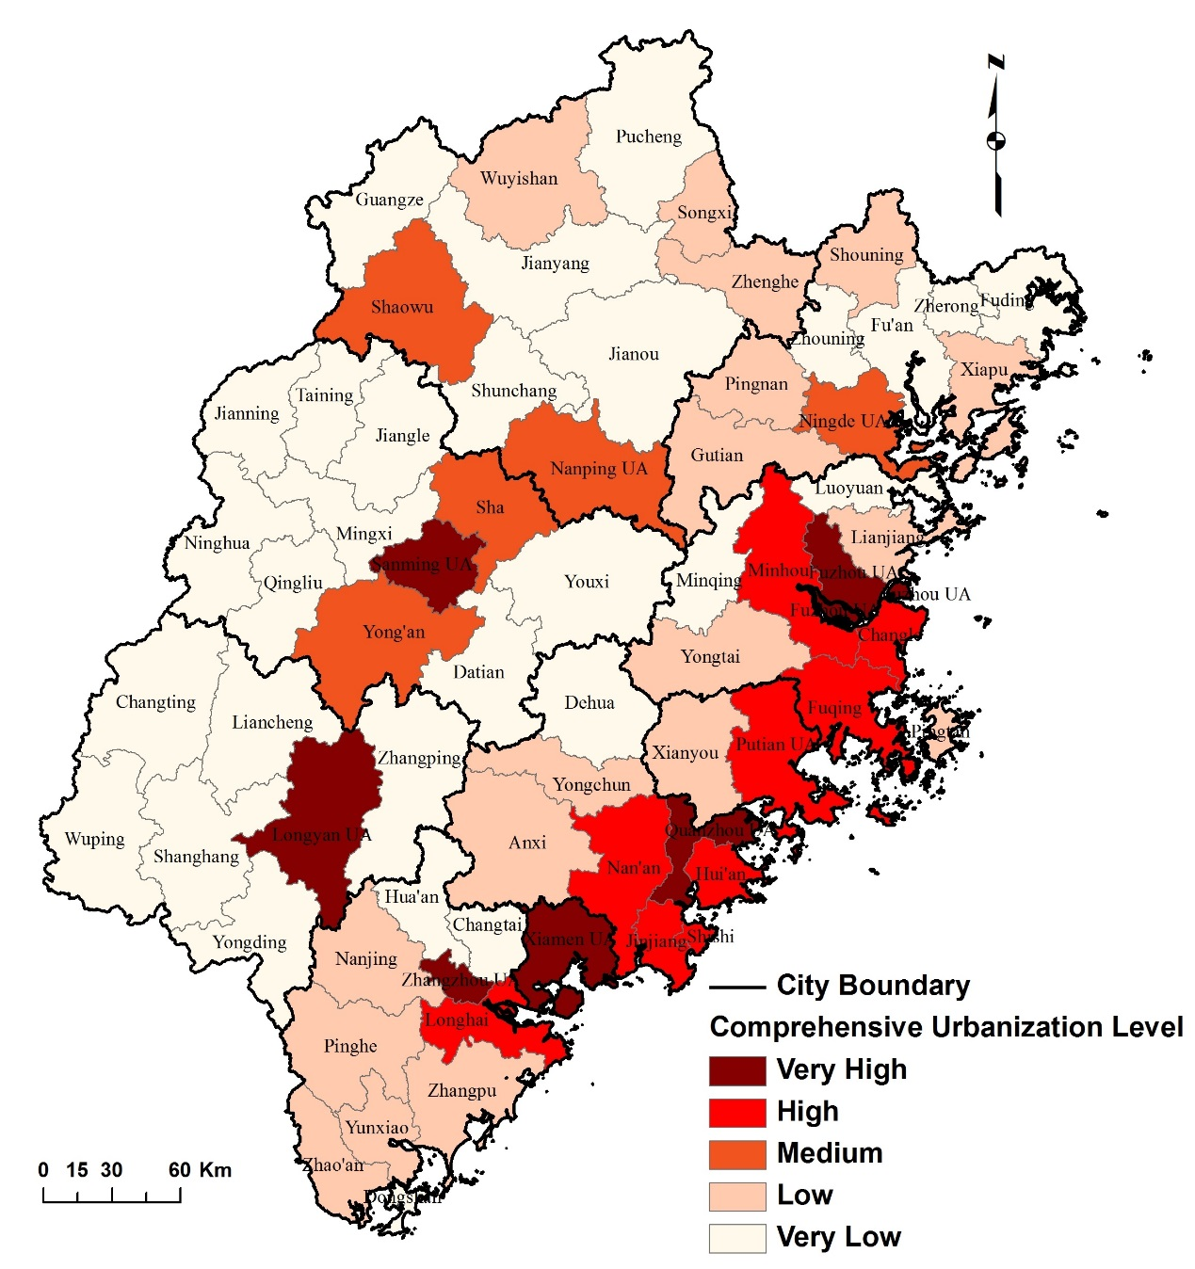
Figure 4. Spatial Disparity of Comprehensive Urbanization Level in Fujian in 2010

4. Conclusion
Based on the above analysis using the comprehensive indicator of urbanization level involving population, economy and society, we obtain following results. (1) The urban areas of the provincial capital city Fuzhou and Xiamen Special Economic Zone are two area units with the highest comprehensive urbanization level. (2) Some urban area units have very high comprehensive urbanization level. All county-level units with high comprehensive urbanization level are all under the administration of the prefecture level cities of Quanzhou and Fuzhou. Due to the prosperity of TVEs, these two area units are well-known for highly developed in-situ urbanization, especially Shishi and Jinjiang. (3) Comprehensive urbanization level in coastal regions is much higher than the inland mountainous regions. (4) The prefecture level city of urban area in Ningde has the lowest comprehensive urbanization level among five coastal cities of Fujian. (5) The ranks of DUL and CUL are different. For example, Xiamen UA, Quanzhou UA, Longyan, UA Putian UA and Nanping UA have higher ranks in CUL than in DUL.
It is more reliable to use comprehensive urbanization level to measure the urbanization process. Comparing with the indicator of demographic urbanization level, the comprehensive one is more integrated to unify the literal meaning of urbanization with population, economic and social changes. In other words, urbanization not only is a process of urban population growth, but also represents the development of urban infrastructure, health care services, culture, education, and so forth. Additionally, the gap between urban population growth and public service, at the backdrop of unscientific development pattern, could be revealed. Due to the integrated characteristics, the indicator of comprehensive urbanization level is more helpful to realize and resolve this discrepancy in the process of rapid urbanization.

Reference
Abdel-Rahman, A., M. Safarzadeh & M. Bottomley (2006) Economic growth and urbanization: A cross-section and time-series analysis of thirty-five developing countries. Rivista Internazionale di Scienze Economiche e Commerciali, 53, 334-348.
Bai, X. M., J. Chen & P. J. Shi (2011) Landscape urbanization and economic growth in China: Positive feedbacks and sustainability dilemmas. Environmental Science & Technology, 46, 132-139.
Chan, K. W. (1996) Post-Mao China: A two-class urban society in the making. International Journal of Urban and Regional Research, 20, 134-150.
--- (2012) Crossing the 50 percent population rubicon: Can China urbanize to prosperity? Eurasian Geography and Economics, 53, 63-86.
Chan, K. W. & L. Zhang (1999) The hukou system and rural-urban migration in China: Processes and changes. The China Quarterly, 160, 818-855.
Chen, A. (2006) Urbanization in China and the case of Fujian Province. Modern China, 32, 99-130.
Chen, M., Y. Huang, Z. Tang, D. Lu, H. Liu & L. Ma (2014) The provincial pattern of the relationship between urbanization and economic development in China. Journal of Geographical Sciences, 24, 33-45.
China Development Research Foundation, C. 2013. China's New Urbanization Strategy. New York: Routledge.
Fan, J. & M. Tian (2003) Relative analysis and provincial differences of China's urbanization and nonagricultural development. Acta Geographica Sinica (in Chinese), 23.
Fang, C. & X. Liu (2009) Temporal and spatial differences and imbalance of China's urbanization development during 1950-2006. Journal of Geographical Sciences, 19, 719-732.
Field, A. 2009. Discovering Statistics Using SPSS. London: Sage Publications Ltd.
FPC. 2013. Tabulation on the 2010 Population Census of Fujian Province (in Chinese). Beijing: China Statistical Publishing House.
FSB. 2011. Fujian Statistical Yearbook 2011 (in Chinese). Beijing: China Statistical Publishing House.
Henderson, J. V. (2003) Urbanization and economic development. Annals of Economics and Finance, 4, 275-341.
Kilkenny, M. (2010) Urban/regional economics and rural development. Journal of Regional Science, 50, 449-470.
Lin, G. C. S. (2001) Metropolitan development in a transitional socialist economy: Spatial restructuring in the Pearl River Delta, China. Urban Studies, 38, 383-406.
Liu (2004) Causal analysis on the regional disparities of urbanization in China. Resources and Environment in the Yangtze Basin (in Chinese), 13, 530-535.
Ma, L. J. C. & M. Fan (1994) Urbanisation from below: The growth of towns in Jiangsu, China. Urban Studies, 31, 1625-1645.
Ma, L. J. C. & C. Lin (1993) Development of towns in China: A case study of Guangdong Province. Population and Development Review, 19, 583-606.
Ning, Y. (1998) New process of urbanization: Dynamics and features of urbanization in China since 1998. Acta Geographica Sinica (in Chinese), 53, 470-477.
OECD. 2000. Reforming China's Enterprises. OECD Publishing.
Orleans, L. A. & L. Burnham (1984) The enigma of China's urban population. Asian Survey, 24, 788-804.
Shen, J. (1995) Rural development and rural to urban migration in China 1978-1990. Geoforum, 26, 395-409.
--- (2004) Reorganizing urban space in China. Restructuring the Chinese city: Changing society, economy and space, 34.
Shen, J., Z. Feng & K. Wong (2006) Dual-track urbanization in a transitional economy: The case of Pearl River Delta in South China. Habitat International, 30, 690-705.
Shen, J., K. Wong & Z. Feng (2002) State-sponsored and spontaneous urbanization in the Pearl River Delta of South China, 1980-1998. Urban Geography, 23, 674-694.
Sit, V. F. S. & C. Yang (1997) Foreign investment induced exo-urbanisation in the Pearl River Delta, China. Urban Studies, 34, 647-677.
Sun, Y., D. Z. Yan & N. Liu. 2009. Research on the Relationship Between Urbanization and Economic Development in Shandong Province. Marrickville: Aussino Acad Publ House.
Tan, C. & Y. Ding (2008) Rural urbanization and urban transformation in Quanzhou, Fujian. Anthropologica, 50, 215-227.
Teng, T. & L. Lin (2012) The correlation between basic public service and regional economy based on an empirical analysis of 13 cities of Jiangsu Province. Contemporary Economy & Management, 34, 61-66.
Wang, G. (2010) Urbanization: Core of China economic development mode transition. Economic Research Journal (in Chinese), 45, 70-81.
Wei, Y., Dennis (2001) Decentralization, marketization, and globalization: the triple processes underlying regional development in China. Asian Geographer, 20, 7-23.
Wu, F. (1997) Urban restructuring in China’s emerging market economy: Towards a framework for analysis. International Journal of Urban and Regional Research, 21, 640-663.
Wu, L., W. Wu & T. Wu. 2003. From the world urbanization trends to see China's urbanization development. In Science News (in Chinese). Beijing, China: Science News Magazine Agency.
Yan, X., C. Lin & X. Xu. 1994. Geography, Region, City (in Chinese). Guangzhou: Guangdong University Education Press.
Zhu, Y. (1998) 'Formal' and 'informal' urbanisation in China: Trends in Fujian Province. Third World Planning Review, 20, 267.
--- (2000) In situ urbanization in rural China: Case studies from Fujian Province. Development and Change, 31, 413-434.
--- (2002) Beyond large-city-centred urbanisation: In situ transformationof rural areas in Fujian Province. Asia Pacific Viewpoint, 43, 9-22.
Zhu, Y., M. Lin, L. Lin & J. Chen (2013) The extent of in situ urbanisation in China's county areas: The case of Fujian Province. China Perspectives, 43-52.

