Unit 7 XSLT Group Exercise
Style the full_directory.xml file using a mix of XSLT and HTML following these guidelines:
- Select elements first_name, last_name, title, address, city, region, postal_code and print in a table.
- Use these literal elements (HTML code) to create the table:
  - create table headings using (th)
  - in table header use bgcolor=”LightSeaGreen” (or whatever color you wish)
  - table rows should be bgcolor=”Goldenrod” (or whatever color you wish)
  - table border=“1”
- Sort all of the employees by their last names in “ascending” or alphabetical order.
- Only display employees who list their region equal to WA.
Notes:
- Make sure your XSLT is well-formed.
- Use IE to look at your XSLT transformation via Notepad++, Click RunLaunch in IE.
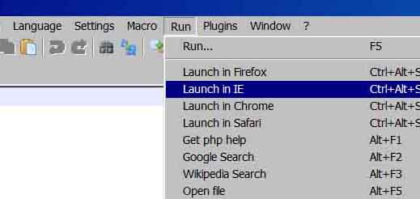
- If you use the Notepad++ for the transformation to view your newly created HTML code. Save it as an HTML file then open it in a browser.
- Set up your XSLT file starting with the table and table header, then proceed with creating a loop to loop over all of your selected elements.
- Set up your sort command and your conditional if statement last.
Here’s what your output file should look like:
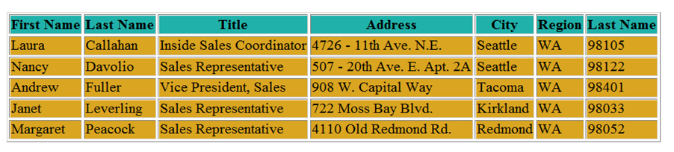
Once you completed the exercise, post the .xsl file to the discussion board. Due Monday July 13th^{th}.

