Installing XML Spear Instructions
- Navigate on the web to http://www.donkeydevelopment.com/
- Click on Downloads, left hand side:
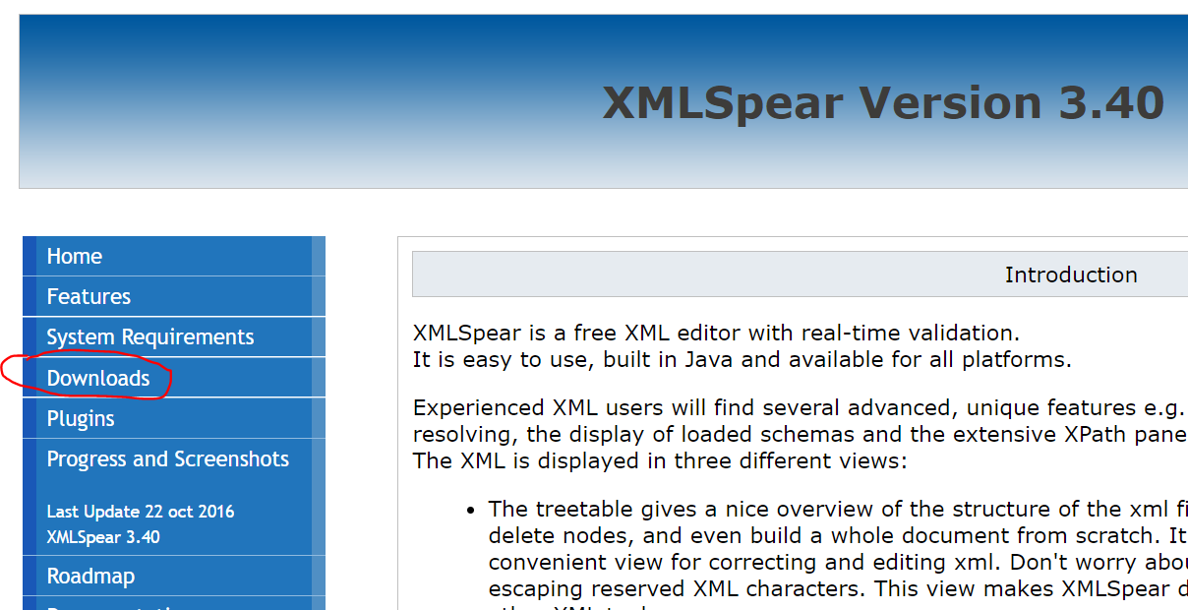
- Download for Windows 10
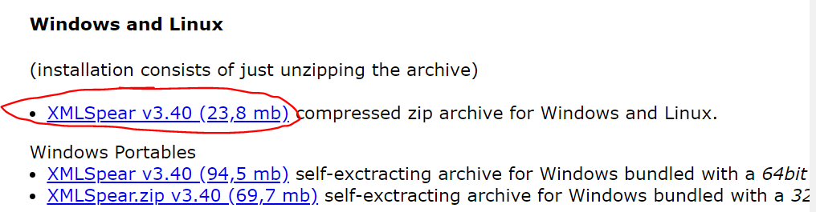
- Navigate to your downloads folder and right-click, Extract All
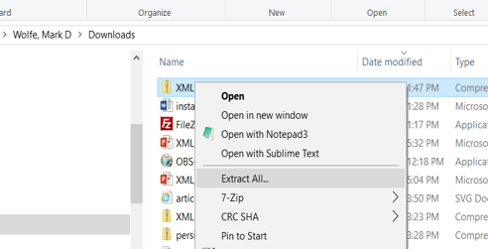

- Navigate to ZMLSpear folder, and double click .exe file to complete installation.
