Directions for Installing Notepad++ and the XML Tools Plugin
Installing Notepad++

- Go to the Notepad++ page: https://notepad-plus-plus.org/download/v6.7.9.2.html
- Download the “Installer” version. Once it’s downloaded, click on the installer.exe.

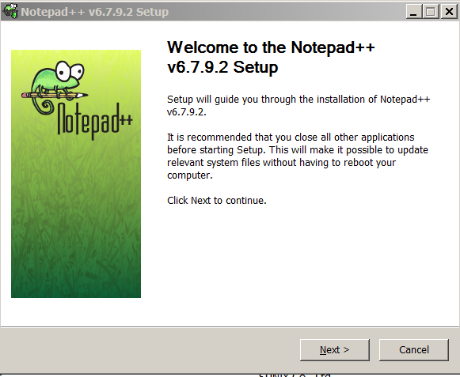
- Click Next, to start the installation and Next and accept the License Agreement.

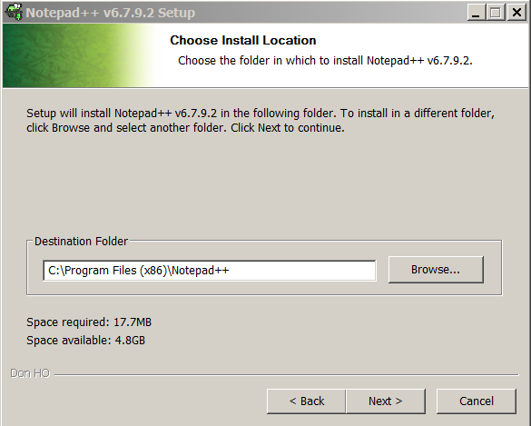

- Install in the default destination, click Next
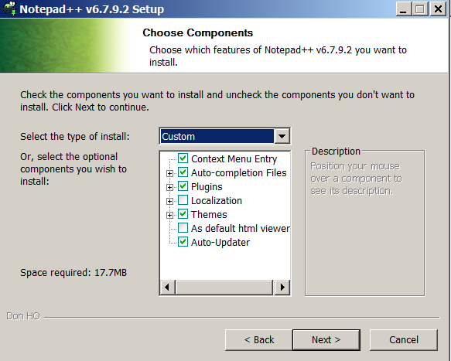
- Click Next without changing default components.

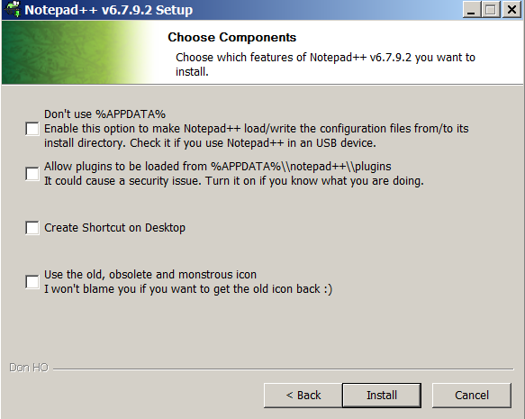

- Leave radio buttons unchecked except for Create Shortcut if you please, and then click Install

- Check to see if the XML Tools plugin is installed on the tool bar under Plugins XML Tools. If not, follow directions below.

Installing XML Tools Plugin

- Click on Plugins->Plugin Manager->Show Plugin Manager
- Scroll down the list of plugins on the “available” tab. Click the radio button for XML Tools. Click install.
- You will be prompted to restart the application, please proceed.
- Close Notepad++ if open, and re-launch. Click Plugins on the tool bar and you should see XML Tools installed.
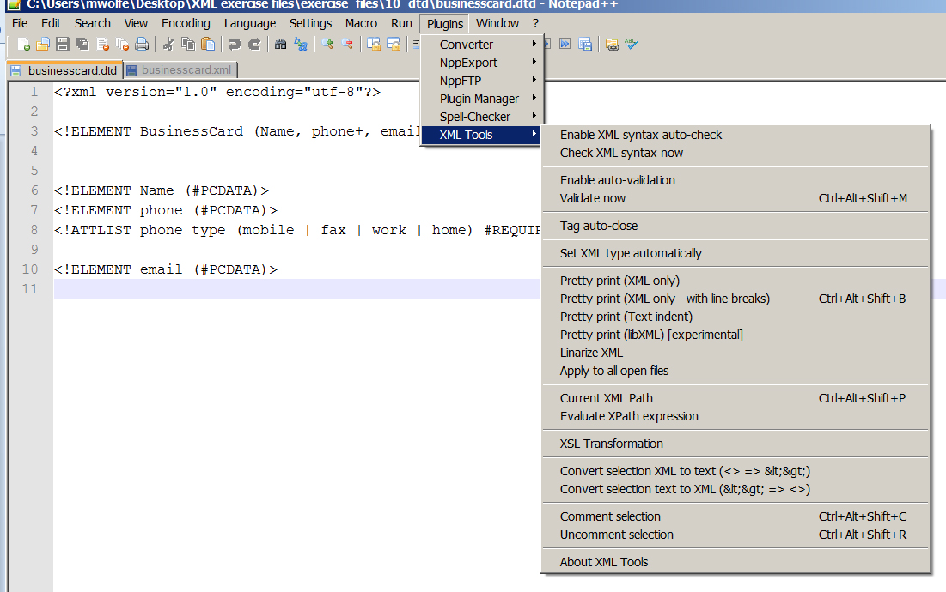
You should see all of these tools.

