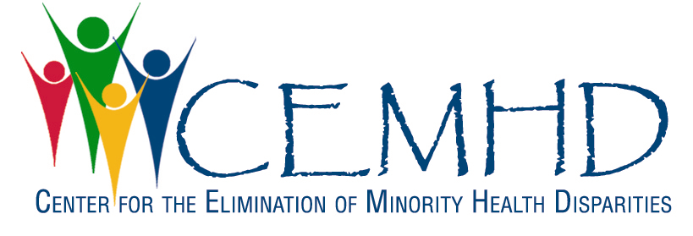
Center for the Elimination of Minority Health Disparities
Presents
Community – Campus Partnerships to Eliminate Health Disparities: SUNY Works in Progress
October 7 – 8, 2010

October 7
Plenary Speaker
Dr. Garth Graham, Deputy Assistant Secretary, Office of Minority Health, Dept. of Health and Human Services
(D’Ambra Auditorium, Life Sciences)

Talks
“Community for Healthy Living: Participatory Process”
“Socially Just Research with Native Americans”
“Racial and Ethnic Health Disparities in a Rural County”
“Why Bother to Use a Condom? I Get Tested”
“Beware of Being Unaware: Racial Ethnic Disparities in the Awareness of Major Chronic Illnesses”

OPEN TO ALL with RSVP

October 8
Keynote Speaker
Wilma Waithe, Director, Office of Minority Health, NYS Dept. of Health
(Room 1143, Life Sciences)

Talks
“Connecting Communities for Health and Wellness”
“Albany Youth Health Program”
“The Women’s Health Project: One Year In”
“Conducting Health Disparity Research: Gaining Insight from Community Residents”
“Assessing Reproductive Health Disparities Among Low-Income Rural Women”
“Health of Latin Family Caregivers”

For further information and RSVP contact:
LKaiser@albany.edu or 442-4904

